**LAB REPORT 7**

**Name:- Ayush Kumar Gupta**

**ROLL NO:- 2023114001**

**1.OBJECTIVE: To Make a Memory unit using basic Gates**.

**ELCTRONIC COMPONENTS REQUIRED -**

1. 3-Input AND Gate IC(74HC11)
2. OR Gate(7432) and Not Gate(74HC04){In LAB}

Or, NOR Gate(74HC02){In TinkerCAD}

1. Digital Circuit

**PROCEDURE:**

1. Test the ICs, LED Lights and Switches.
2. Connect ICs with GND, Power.
3. ­­­­­­­Connect the circuit as given in reference circuit. 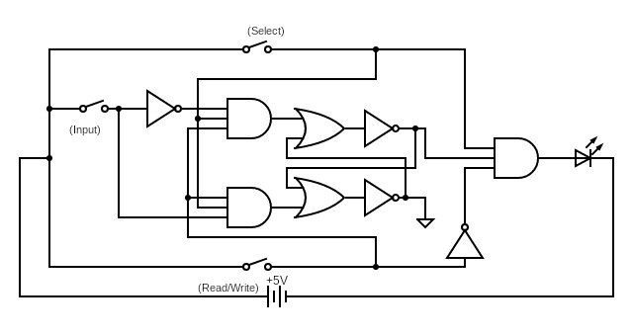
4. Check the output with Combination.

Conclusion:

|  |  |  |  |
| --- | --- | --- | --- |
| Select | Read/Write | Input | Output |
| 0 | X | X | 0 |
| 1 | 1 | 0 | 0 |
| 1 | 0 | X | 0 |
| 1 | 1 | 1 | 0 |
| 1 | 0 | X | 1 |

1. When Select Line is 0, The Output was always 0.
2. When Select Line is 1,
3. If Read/Write is 0 i.e. Read, It reads the previous input assigned by Write, Latched input.
4. If Read/Write is 1 i.e. Write, It writes the input assigned in memory through Latching.

**LINK FOR TINKERCAD SIMULATION :**

[**https://www.tinkercad.com/things/fOKh71KqMS4-memorybomb/editel?sharecode=EO_4NM3RodMskeuEOpK-L0xciWsu4Ip11kXTKk34oTQ**](https://www.tinkercad.com/things/fOKh71KqMS4-memorybomb/editel?sharecode=EO_4NM3RodMskeuEOpK-L0xciWsu4Ip11kXTKk34oTQ)

**TINKERCARD :**

LAB:

